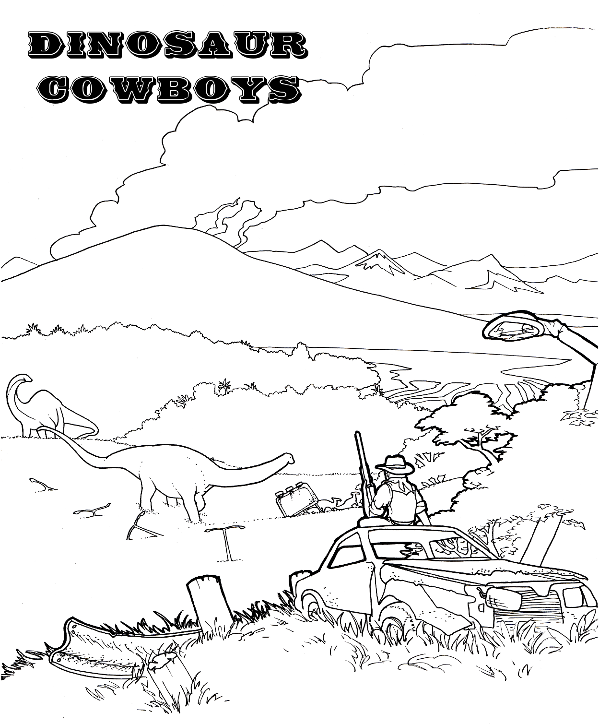
A skirmish game where prehistoric dinosaurs meet the new wild west of 2285
Table of Contents
Game Overview 4
What is Needed to Play 5
History 6
Statistics Overview 10
Miscellaneous 10
Number Rounding 10
The Turn 11
Movement Phase 12
Action Phase 13
Combat 14
General Combat Procedure 14
Range Combat Special Cases 15
Close Combat Special Cases 16
Combat Examples 17
Bravery Test 18
Dinosaurs 19
Dinosaur Discipline 20
Traits 22
Standalone Game 25
Tips for New Players 26
Deployments 27
Objectives 30
Features 32
Hiring a Posse 36
Hiring a Character 38
Hiring a Dinosaur 41
Posse Roster Example 44
Campaign Game 45
Overland Travel 46
Wounds and Injuries 49
Posse Advancement 50
Variant Rules 53
Weapons and Armor and Equipment 55
Weapon Special Abilities 56

Table of Objects
Combat Modifiers 15
Active Traits 23
Passive Traits 24
Character Statistics 39
Defense IP Costs 39
Range Target Number IP Costs 39
Close Target Number IP Costs 39
Bravery Target Number IP Costs 39
Hitpoints IP Costs 39
Speed IP Costs 39
Dinosaur Hitpoints Advancement Costs 41
Dinosaur List 42
Overland Terrain Types 48
Out of Action Effect (Human) 51
Out of Action Effect (Dinosaur) 52
Range Weapons 1/5 58
Range Weapons 2/5 59
Range Weapons 3/5 60
Range Weapons 4/5 61
Range Weapons 5/5 62
Close Weapons 1/2 63
Close Weapons 2/2 64
Natural Weapons 65
Armor and Medical Devices 66
Blank Posse Roster 67
Custom Game Sheet 68
Campaign Record Sheet 69
Quick Reference Sheet 70

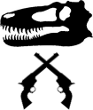
Version: | 2.6 (2015)
Game Author: | Carlo Guglielmin
Cover Art: | Erik Spohn
Sepia Interior Art: | Library of Congress
Website: | http://dinosaurcowboys.com/
Email: | carlo@dinosaurcowboys.com
Posse Designer: | http://saloon.thruhere.net/
License: | Creative Commons Attribution-NonCommercial-ShareAlike 3.0 Unported License

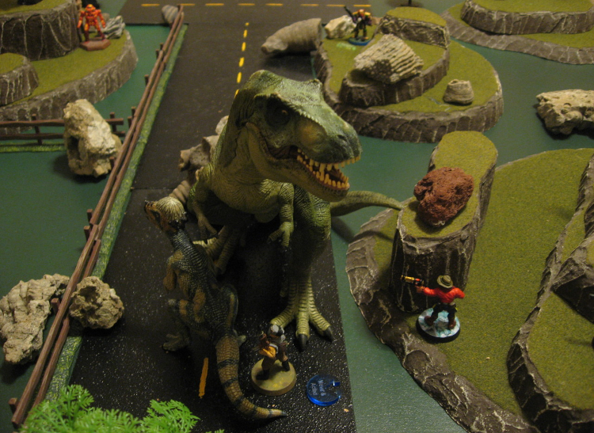

Game Overview

Dinosaur Cowboys is a fast playing (45 to 60 minutes) miniatures skirmish game of competing Posses composed of up to five members and a dinosaur. Each character in the Posse can be customized to fulfill a different role and purchase weapons and equipment from the many options available. Combat takes place in the futuristic landscape of the year 2285, where a supervolcano erupted and changed the course of mankind forever.

The way to set up and play Dinosaur Cowboys will be familiar to anyone who has experienced other tabletop skirmish, roleplaying or wargames.

Each player leads a Posse of characters (such as a sly gunslinger, a rich noble explorer, an old weary lawman, etc.) through conflicts in the futuristic world outlined below. Posses offers a high level of customization including modifying statistics and buying various equipment.
Players can battle head to head in a standalone skirmish, or link their fights together into an ongoing campaign woven with narrative, travel, exploration, purchases, and more. Players can choose different deployments, objectives, and features to ensure each skirmish is unique and fun.

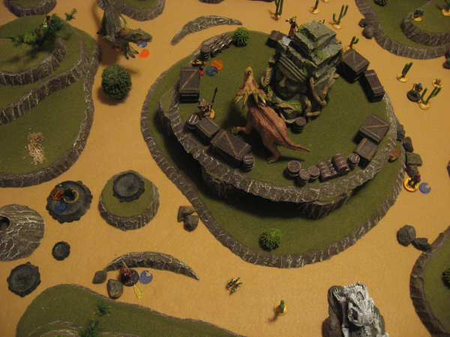
Dinosaur Cowboys is played using 28mm miniatures to represent characters and dinosaurs, but other scales work just as well. These miniatures will move and fight across tabletop terrain. The actual pieces of terrain can vary from high quality styrofoam plots of land and handcrafted trees to a simple cloth mat spread over stacks of books to make bumpy hills.

What is Needed to Play
To play a game of Dinosaur Cowboys a few hobby supplies are needed:

- 45 to 60 minutes of time (more terrain, players, and stronger Posses will increase playtime)
- This rulebook
- 1 Posse Roster per player (a blank copy is at the end of this rulebook)
- Pencils and erasers
- Measuring tape or stick
- A flat surface to play on (normally 4'x3') with representations of terrain
- 28mm character miniatures or figurines
- Multiple 12-sided dice (referred to as D12s)
- A few 6-sided dice (referred to as D6s)
- Token markers for Activated, Fleeing, Panic, Reload, Stunned, Slowed, Stopped
  - These can be simple scraps of paper, colored beads, discs of wood, or custom made plastic tokens

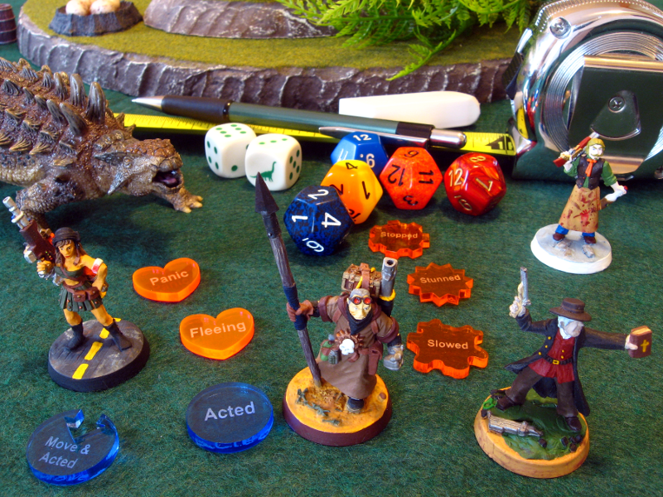

History

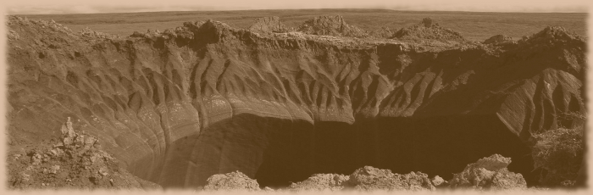
Prehistoric Chamber
In the savage time when dinosaurs ruled the Earth, roiling volcanoes rapidly changed the landscape with stunning ferocity. The thick forests and grasslands of what would eventually become Wyoming were home to such a volcano. Scalding magma thundered through underground chasms of solid rock, venting boiling steam to the surface through numerous geysers.
The intensity of the volcano increased until finally the lava broke through the crust in an unmatched eruption. An expansive magma chamber below the surface was emptied as the fiery liquid engulfed trees and dinosaurs with equal hunger.
Normally the roof of such hollows would collapse inwards, forming a caldera, as magma was no longer available to hold up the thick layer of dirt. By chance, the hearty rock failed to crack or tumble, resulting in a vast, scorched chamber.
Hundreds of miles wide, the room unexpectedly provided sanctuary and shelter for weaker dinosaurs that wandered inside. Soon larger, cunning predators innately tracked and followed their prey into the chamber. The desperate battle for survival continued unabated beneath the surface.
Smaller beasts ferried seeds and plant life into the cave, using the nooks and crannies of the rock as their own personal cellar. Sunlight pierced the darkness through porous roof, providing nourishing energy to the growing vegetation below.
In time, the shifting Earth brought a new flow of unyielding lava, but the burning sea passed above the chamber, warming and cooling with the passing of seasons. Unharmed, but trapped by hardened rock, life tenaciously continued in the enclosed ecosystem for millions of years.
Dirt and silt blew across the solidifying magma, eventually forming a new layer of soil above the chamber. In time sweeping forests would regrow and the venting volcano would be named Yellowstone National Park by the humans that came after. The millions of tourists eagerly watching the erupting Old Faithful geyser had no idea of the prehistoric time capsule buried beneath the surface.

Eruption Day
On a quiet, spring day in the year 2037, the aggravated supervolcano erupted again. Scientists monitoring the geyser used their last seconds alive to futilely throw their hands up in surprise and scoff before lava poured over the surrounding buildings. As before, magma was agitated to the surface, flooding the entire park in unrelenting heat.
The supervolcano tore asunder the chamber roof, cracking stone that had long held the lava at bay. Great clouds of dust were thrown into the air, and titanic amounts of stored gas eagerly escaped from the chamber.
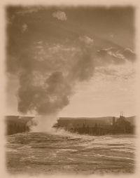
Long caged in the hollow the gases gleefully mingled with the carbon dioxide in the atmosphere, corroding and damaging the ozone layer. The result was exponential amplification of the greenhouse effect, heating the entire Earth with increased solar rays.
As the expended lava again cooled and hardened, new pathways were opened to release the dinosaurs. Swarming across the land in great herds, the hungry creatures eagerly searched for new pasture and new hiding places from carnivores.
Calm after years of war, the United States of America had no strategy and no escape plan to stem nature's wrath. Increasing temperatures caused polar ice caps to melt and raise the water level of the Earth's oceans, resulting in coastal areas being drowned.
The eastern coast was hit the hardest as every city and carefully paved road were washed away. Bustling Time Square in New York became a floundering pool of rusted buildings populated by darting schools of fish.
On the western coast San Francisco and Los Angeles dissolved into distant memories. Millions of people were killed as the great cities were flooded and lowered to the floor of the widened ocean.
Eventually the chaotic tide slowed and broke at the Mississippi river, leaving numerous prairie towns with a new ocean view.
As expected the populace panicked. A massive migration began away from the volcanic remnants of Wyoming and the reformed coasts. The southern deserts became unbearable wastelands with temperatures soaring to water's boiling point.
Canada to the north was covered in ash and eventually emptied as unprepared citizens escaped the cold by fleeing south. The country remains forsaken and abandoned, covered in blowing snow and choking ash and ruled by dangerous creatures. Rumors persist that Alaska endures untouched by the eruption's devastation; a rugged utopia for those brave enough to explore northwards.
After the chaos the darkest years of humanity's existence followed. Scavengers and savages ruled the cities as communications and technology broke down. Electricity was scarce and food even scarcer. Horrible acts of violence and torture filled every street and town in an all-consuming apocalyptic whirlwind.
Mankind was on the brink of extinction.

First Contact
Fifty two years after the eruption, a caravan of explorers travelling from Reno, Nevada to Fargo, North Dakota made a startling discovery. The previously desolate, blackened rocks around the volcano had become a lush jungle.
Baffled by this discovery, the group continued to explore the strange, unrecognizable plant life. Unlike the sandy deserts that consumed the rest of the continent, the temperatures inside the jungle were comfortably warm; almost tropical. Veins of rich metal had been exposed by the turmoil, and the endless tangle provided rich lumber resources.
Their excitement became terror as a hulking Tyrannosaurus Rex chased and devoured three of the crew. The rest fled, wild with fear and confusion. They stopped at the first safe town they came across, called Alliance, Nebraska. Dismissed as men gone mad from the sun, the retelling of the story of a veritable paradise did little to rouse the attention they had expected.
However, eventually the rumors travelled. By 2091 numerous big game hunters, adventurers, and entrepreneurs flocked to the jungle.

Reconstruction Begins
Two years later in 2093 a brave young scientist named Doctor Emilee Viator gathered a crew of experienced trackers, industrious farmers, and brave warriors. Calling themselves the Neotechnoists, the historic party of thirty created the first permanent settlement in the jungle, near the old world town of Cody, Wyoming.
Built high in the trees and protected by organized sentries, the town was designated Haven. Nestled in the home territory of the dinosaurs meant Dr. Viator achieved stunning progress in the study and understanding of the ancient creatures.
Soon settlers converged on Haven, eagerly leaving the unforgiving deserts for a chance at a new life in the jungle. With renewed help and a resolute vision of the future, Emilee began expanding her town and molding the jungle to suit the needs of mankind.

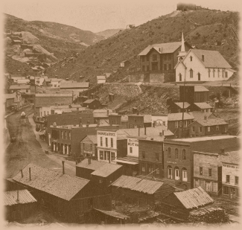
The Wall
By 2129 Haven was the capital of a fledgling empire. Half the remaining population of the United States called the jungle their home, while the stubborn other half refused to leave their dusty shelters in the wide open plains surrounding the location.
Incentive programs were created, and soon even the staunchest of desert dwellers immigrated to the expanding cities and steel homes of the jungle. Only a mad few remained outside. The populace of the growing empire took the name of their recently deceased founders, and so the Neotechnoist civilization was born.
By harnessing the raw power of dinosaurs in the place of dwindling crude oil, gleaming spires and reinforced bunkers soon stretched across the entire jungle. The jungle and associated tropical climate had also expanded, overrunning all of Wyoming plus the neighbor states of Idaho, Montana, and pieces of their outside borders.
Mankind had seemingly restored itself to the ease of modern living.
United under a single banner, the seventeen million Neotechnoists began constructing their largest project to date. Harvesting chunks of lava rock from thousands of quarries, an imposing wall was erected to circle the jungle. This succeeded in protecting the populace from roaming feral beasts. Some dinosaurs had fled the intrusive encroachment; their primordial instincts no match for the relentless march of humans.
The Wall was fifty feet high and five feet thick, with heavy metal gates blocking all the roads leading out to the jungle. But a barricade works both for and against those it surrounds, and soon the people forgot their desert upbringing; forgot everything but the Neotechnoist way.

Discontent Rumblings
The upper class nobles of Haven soon grew bored by the tedious routine of peace. Having being raised to treat dinosaurs like simple cattle, the new apathetic generation were enamored and mystified by the untamed wild lands outside The Wall.
In 2203, the first group of wealthy and rebellious youth fired their grappling hooks over the top of The Wall, and snuck away into the desert. Much like the first explorers of the jungles, the band brought back tall tales of untold riches and exciting dangers that enticed some of the weary, languid Neotechnoist population.
Soon not just rich nobles were going over The Wall, but the downtrodden peasants and oppressed working class. Exploited and helpless, the lower class were eager for a chance at a new life. Whispers of free, unclaimed land as far as the eye could see drew pioneers to depart into the forgotten deserts.
Angry at the loss of their servants, the ruling lords of Haven outlawed leaving the jungle. But the strict penalties and harsh sentences just increased the forbidden lure of the desert. By 2218, close to one-third of the population had abandoned the Neotechnoist way to live free and unhindered in the dangerous desert.

A Movement is Born
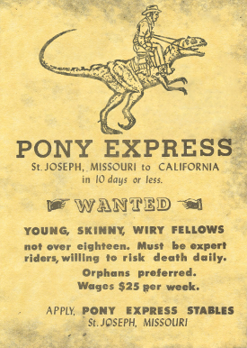
Those that grappled and trained wild dinosaurs, built rickety towns of wood and sweat, and enjoyed the riches of their labors became unrecognizable as Neotechnoists. The unorganized bands and roaming gangs began calling themselves Dusters. Soon the nomenclature had even slipped into the speech of the jungle people.
To the Neotechnoists these scraps of humanity were considered primitive and rough. In return the Dusters called the jungle people Volkies (for their proximity to the volcano) or Veggies (for the vegetarian diet most Neotechnoists indulged in).
The small population that had permanently remained outside The Wall amidst the chaos and danger clashed with the Dusters. Wild and brutal by any standards, these Savages were in turn looked upon by the Dusters much as the Neotechnoists looked upon them.
The lonely, dusty towns outside The Wall resembled something from an old wild west movie. A rustic frontier attitude emerged thanks to the mass of explorers and settlers. Embracing the romantic imagery of a distant past, the Dusters began dressing like cowboys and outlaws of nearly 400 years earlier. Wrangling dinosaurs for transportation, food, and protection, the new cowboys began to slowly rebuild a very different world than the Neotechnoists.

Present Day
The year is 2285, and the first generation of Dusters are beginning to succumb to old age. Never experiencing a time before they lived in the desert, the next generation continue their simple, dangerous lives. Safely inside The Wall the civilized Neotechnoists also maintain their advanced, controlled lifestyles. Meanwhile the Savages remain a constant, dangerous threat to anyone.
Humanity and dinosaurs have assimilated and recovered their strength and dominion. However the Dusters and Neotechnoists look towards an uncertain future, split by class, distance, customs and traditions.

Statistics Overview

Each entity in the game is represented by a set of statistics, which are used to determine how fast they are, how well they attack, etc. This section will briefly define each statistic to help clarify subsequent examples.

Our example character, which we detail further in the Hiring a Character Example section, is named "Quidel". You can see that he is a Duster Leader. "Duster" is a type of Allegiance, which modifies his statistics slightly and provides some flavor to the character.

Quidel (Duster Leader)
DEF 2, RTN 7, CTN 7, BTN 7, SPD 3, HP 14

DEF (Defense): How difficult attacking this character is. A higher Defense is better. Defense directly modifies what an attacker needs to roll to hit for all types of combat.
RTN (Range Target Number): How skilled a shooter this character is. This number is used as the base to hit roll, so lower is better.
CTN (Close Target Number): How skilled this character is in close combat or melee. This number is used as the base to hit roll, so lower is better.
BTN (Bravery Target Number): How brave and courageous a character is. This number is used as the base for a Bravery Test, so lower is better.
SPD (Speed): How fast a character is. This is the number of inches a character can move, so higher is better.
HP (Hitpoints): How much punishment and damage a character can suffer before they are out of action. A higher number of Hitpoints is better.

Miscellaneous

Game Terms
Character or Human: Leaders and Members of Posses, these terms refer to human entities.
Dinosaur: Represented by larger miniatures, refers to anything that uses the Dinosaurs rules.
Entity: A character, dinosaur or other creature. Basically one "thing" represented by a miniature.

Number Rounding
Unless specified otherwise, always round down.
For example 18.5 becomes 18, or 7 divided by 3 is 2, or 1 divided by 2 is 0 instead of 0.5, etc.

Re-Rolls
If a rule allows a re-roll the second result must be used, even if it's worse than the original.

Healing
An entity affected by an item, trait, effect, etc. that heals Hitpoints can never exceed their total starting Hitpoints.

The Turn

During combat situations the passage of time is tracked using turns. Each turn allows players to use their entities to perform various actions.

- Refresh
- Initiative
- Activation
- Repeat

Step 1/4 - Refresh
Remove Activated tokens from all entities at the start of each turn.

Step 2/4 - Initiative
Each player rolls a D12 (re-roll any ties). Whoever rolls highest currently has Initiative and chooses an un-Activated entity to Activate. Once finished, the player with the next highest Initiative roll will Activate.
For example Jim rolls a 10 for his Initiative and Sally rolls a 6, so Jim currently has Initiative.

Uneven Entities: During this step count the ratio of un-Activated entities between each player. If the ratio is uneven (not 1:1) the numerically superior player must Activate additional entities.
For example Jim has 5 entities and Sally has 3 (not a 1:1 ratio, but not quite a 2:1 ratio):
First Activation (Jim wins Initiative): Jim Activates 1 entity, then Sally responds with 1.
Second Activation (Sally wins Initiative): Now the count of un-Activated entities is 4 to 2, so a 2:1 ratio for Jim. That means Sally 1, Jim 2. Also Sally kills 1 of Jim's characters.
Third Activation (Sally wins Initiative): Since Jim lost an entity the count is now 1 entity to 1, so back to a standard 1:1 ratio. Sally 1, Jim 1.

Step 3/4 - Activation
The Activated entity can first use their Active Trait(s), then perform the Movement Phase and Action Phase (in either order). When finished mark the entity with an Activated token.
For example Jim wins Initiative and decides to Activate his dinosaur. He performs the Movement and Action Phase for that entity. Once finished he places an Activated token beside the dinosaur. Then Sally would respond by Activating her own entity.

Skipping Phases: One or both Phases can be skipped if desired (for example an entity does not have to perform their Movement Phase). If skipped they still count as having been Activated.

Step 4/4 - Repeat
Once every player has finished their Activation, repeat Step #2. When no un-Activated entities remain the turn is over.

Movement Phase
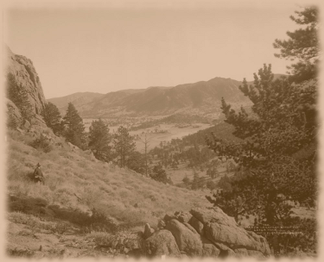
Maneuver - Standard Move
Move the entity any number of inches in any direction up to the entity's Speed statistic. Do this by measuring from the front of the entity's base/stand to the point you want to move.
Moving at least 2"+ makes an entity harder to attack.

Facing: Entities can see and fire 180 degrees in front of them. Use the direction of the miniature's feet to decide which way is forward.
Facing can only be changed during the Movement Phase (at no cost), but once decided it remains the same until their next Activation.

Moving Through Entities: A character can move through allied entities, but not through enemy entities. A dinosaur can move through allied entities and enemy characters but not enemy dinosaurs.
An entity cannot end their movement occupying the same space as another entity.

Difficult Terrain: Any terrain except flatlands is considered Difficult Terrain (trees, hills, cliffs, rubble, water, etc.).
Characters must double the Speed cost while in Difficult Terrain.
For example a character would use 4" of Speed to climb a slope 2" high (2"x2). Alternatively to move through a 6" wide jungle (Difficult Terrain) a character would use 12" of Speed (6"x2).

Falling or Push Damage: If an entity falls or is Pushed into an impassable or solid object they take 1 damage for every 1" of distance (only count distance they actually moved).
For example a character by a wall is hit by a Riot Grenade and the Pushed effect sends them 4" backwards into the wall. In addition to the attack they would reduce their HP by 4 damage for being Pushed 4" into a solid object.

Action Phase
During the Action Phase an entity can perform a single complex task, such as firing a gun, running further, or applying a medical device.

Action - Use a Weapon
Perform an attack with either a range weapon or a close weapon (see the Combat section).

Action - Use a Medical Device
Apply a Medical Device from the character's inventory to themselves or an adjacent allied entity. The Medical Device is consumed upon use and removed from the user's inventory.

If the Type was Instant, apply the Heal effect immediately.
Otherwise if the Type was Delayed, apply the Heal effect at the start of the user's next Activation.

Action - Reload a Weapon
A weapon the character has is reloaded. Remove the Reload token from that weapon.

Action - Hustle
Perform a Standard Move using half the entity's Speed statistic (minimum 1).
For example an entity with 4 Speed could Hustle an additional 2" for a total of 6" during their Activation, whereas an entity with a 3 Speed could Hustle an additional 1" for a total of 4".

Action - Charge
If an enemy is within 2-6" and the attacker has a close weapon (excluding Brawl and Beast types) they can risk a Charge. Measure the shortest straight line between the attacker and the target and roll a D6. Count the roll as inches.

If the roll as inches is enough to reach the target (including Difficult Terrain where applicable) the Charge can be completed. Move the attacker into adjacent contact with the target and perform a close combat attack with the Charge bonus.
For example the attacker is 5" away from their target. Assuming clear terrain they would need to roll a 5 or 6 on the D6 roll to be able to reach the target and complete the Charge.

Otherwise the Charge cannot be completed; the attacker does not move and cannot do anything else this Action Phase. A roll of 1 will always fail, regardless of Traits or modifiers.

Action - Mount or Dismount
A character can Mount an adjacent dinosaur, or Dismount an existing one (see the Dinosaurs section).

Combat

Since the dawn of mankind there has been violence. The re-emergence of dinosaurs has done little to slow the carnage. Battles can be fought at a distance or in hand to hand.
This section will outline the rules for simulating fights between Posses and the various people and creatures who wish them harm.

Weapon Statistics
Each weapon has a set of statistics to represent how it functions in combat, such as:

Weapon Name: Name of the weapon, in this case the most common six-shooter.
Statistics A: The Attack (A) statistic, which determines how rapidly a weapon can fire or be used.
Statistics D: The Damage (D) statistic, which determines how much base damage a weapon will do when hitting a target. Combined with Attack this is often abbreviated as 4A-0D.
Distance: How far the weapon can attack, listed as Short, Medium, and Long.
Reload: Reload value which determines how reliable a weapon is. A higher number is better.

Range Attack
If the attacker can see the target (both Line of Sight and Facing should be checked) and are within the maximum Distance of their weapon, they can attack in the Action Phase with a range weapon.

Close Attack
Two or more combatants are considered in close combat (also know as melee) if they are adjacent, regardless of Facing or elevation. They can attack in the Action Phase with a close weapon.

General Combat Procedure
Step 1/3 - Attack Roll
Roll a D12 for each Attack of the range or close weapon. Include any bonus Attacks.

Step 2/3 - Determine Hits
Use the Range Target Number for range weapons, and Close Target Number for close weapons.
Apply any modifiers to the associated Target Number. Every Attack Roll greater than or equal to the modified Target Number is a Hit.

Attack Roll >= (Target Number +/- modifiers) = Hit

Critical Hit: Every unmodified Attack Roll of 12 is a Critical Hit and counts as 2 Hits, unless a 12+ was needed to hit.

Automatic Hit and Miss: An Attack Roll of 12 is always a Hit, and a result of 1 is always a miss, both regardless of Target Number and modifiers.
Step 3/3 - Apply Damage
Add the count of all Hits to the weapon Damage statistic (which may be 0). Apply any modifiers to the total. Subtract this number from the target Hitpoints to get their new Current HP.

Hitpoints - (count of Hits + weapon Damage +/- modifiers)

Out of Action
If an entity is reduced to 0 or less Hitpoints they are Out of Action. Immediately remove them from the table.

Modifiers
The ability for an attacker to hit their target can vary depending on various conditions which are represented by modifiers. The following table outlines how and when modifiers apply:

Elevation
If the attacker is higher than the target by 2" or more (such as on a building rooftop or hill) apply the "Elevation" bonus. Being mounted on a tall dinosaur does not provide this bonus.

Range Combat Special Cases
Line of Sight
Check Line of Sight by getting a "model eye view" of the target. Targets behind solid buildings, tall hills, allied or enemy dinosaurs that are big enough, etc. cannot be seen.

Firing Arc
Entities can see and perform range attacks 180 degrees in front of them.

Distance
Weapons can have a Short, Medium, and Long Distance. A bonus is provided for attacks made at Short Distance, no difference for Medium Distance, and a penalty for Long Distance.
Measure between the attacker (from their base) to the closest point on the target, then apply the corresponding modifier.
Minimum Distance: A weapon has a Minimum Distance if the starting distance number is higher than 0. No attack can be made at targets closer than the Minimum Distance.
For example a 200kW Twin Rifle (which only has 5-18" Long Distance) could not attack targets within 0-4". Similarly a Handcannon (1-8" Short Distance) could not attack targets closer than 1", such as in close combat.

Shot in the Back
Any range attack against the target's back (180 degree arc opposite their front Facing) will be treated as a Critical Hit on 10+ (unless a 10+ was needed to hit). This does not apply to targets in close combat.

Cover
A target is in cover if they are directly behind an obstruction (tree, hill, other model, etc.) that visibly covers them by at least 25%. If so apply the "Cover" penalty to incoming range attacks.

Reloading
Each range weapon has a Reload value as part of their statistics, such as 2x1 or 3x1. This number represents how likely and often the weapon will jam, overheat, or need to be reloaded.

If the count of unmodified Attack Roll dice that rolled 1 are greater than or equal to the Reload value, the weapon needs to be reloaded and cannot fire again until a "Reload a Weapon" action is performed. Resolve the attack then mark the weapon with a Reload token.
For example firing a 300kW Peacemaker (4 Attacks, 1x1 Reload) with rolls of 1, 5, 8, 8. Because there is an unmodified 1 and the Reload value is 1x1, the weapon requires a Reload.

Special Reload Values: If the Reload value is "Auto" the weapon must be reloaded after each attack, whereas "None" means the weapon never has to reload.

Close Combat Special Cases
Charge
If the attacker performed a Charge to enter close combat with the target apply the "Charge" bonus to the first set of attacks.
Note that an entity can enter close combat without using a Charge by simply moving adjacent to the target (in the Movement Phase) and then attacking as normal in the Action Phase. The purpose of a Charge is to reward the risk of potentially failing to reach close combat.

Snap Attack
If a target voluntarily moves or Dismounts during close combat any opponents with a close weapon (excluding Brawl and Beast types) can choose to perform a free set of close attacks against them.
This does not apply to mandatory movement due to Fleeing, Pushed, Pulled, etc.
Firing in (or into) Close Combat
Apply the "In Close" penalty to range attacks made within, out of, or into close combat. This replaces the Short Distance modifier, if applicable.

Brawl Attacks
Brawl attacks (Punch, Kick, Shove, Trip) are special natural weapons always available to any character at no cost. Brawl attacks cannot be used as a Snap Attack or while Charging.

Combat Examples
Firing a 200kW Six-Shooter (4 Attacks, 2 Damage) with 7 Range Target Number. The target has 0 Defense, is at Medium Distance, and is not in Cover, so no modifiers are needed.
Step 1: Roll 4D12 (because of 4 Attacks) resulting in 2, 6, 9, 12.
Step 2: Need a 7+ to hit (due to unmodified 7 RTN), so the rolls of 9 and 12 hit. A 12 is a Critical Hit so it counts as a double hit. In total there are 3 Hits.
Step 3: Add base Damage of the weapon (2) to the total Hits (3) for 5 total damage. Reduce the target's Hitpoints by 5.

Firing a Break-Action Shotgun (2 Attacks, 3 Damage) with 4 Range Target Number. The target has 2 Defense and is at Short Distance in Cover behind a tree. The total Target Number is 5 (4 RTN + 2 Defense - 1 Short Distance).
Step 1: Roll 2D12 (because of 2 Attacks) resulting in 7 and 10.
Step 2: Need a 5+ to hit, so all rolls hit. In total there are 2 Hits.
Step 3: Unmodified total damage is 5 (2 Hits + 3 weapon Damage). Target is in Cover, so modify the damage by -1, for a total of 4. Reduce the target's Hitpoints by 4.

Using a close combat Flail (5 Attacks, 0 Damage) with 8 Close Target Number. The target has 0 Defense.
Step 1: Roll 5D12 (because of 5 Attacks) resulting in 3, 3, 5, 8 and 11.
Step 2: Need an 8+ to hit (due to unmodified 8 CTN), so the rolls of 8 and 11 are Hits.
Step 3: The base Damage of the weapon is 0 in this case, so we just use the total Hits (2) for 2 total damage. Reduce the target's Hitpoints by 2.

Charge with a close combat Spear (1 Attacks, 6 Damage) with 6 Close Target Number. The target has 3 Defense. The total Target Number is 9 (6 CTN + 3 Defense).
Step 1: Roll 2D12 (1 base Attack, plus 1 for Charge bonus) resulting in 4 and 10.
Step 2: Need a 9+ to hit, so the roll of 10 is a Hit.
Step 3: Add base Damage of the weapon (6) to the total Hits (1) for 7 total damage. Reduce the target's Hitpoints by 7.

Bravery Test

Bravery Tests represent a character trying to maintain their will to stand and fight against tremendous and terrifying odds or situations. Failure represents running away like a coward.
This section will explain how and when to take a Bravery Test and the consequences of failing.

When to Bravery Test
- Immediately after an allied Leader is taken Out of Action.
- If a character suffers damage greater than or equal to half their starting Hitpoints statistic from a single range or close combat attack.
For example a character had 10 starting Hitpoints. They suffer 7 damage from an Ultra Burst Rifle, which is higher than 5 (half their starting Hitpoints) so they must perform a Bravery Test.

Damage >= (starting Hitpoints ÷ 2) = Bravery Test

How to Bravery Test
Roll a D12 for the Bravery Test. If the result is greater than or equal to the character's Bravery Target Number they succeed and nothing happens.
Otherwise the Bravery Test is failed and they are Fleeing. Mark them with a Fleeing token.

D12 >= Bravery Target Number = success, otherwise Fleeing

Bravery Test While Mounted: If a character is mounted on a dinosaur (with no Panic tokens) they modify their Bravery Target Number by -1 for any Bravery Test.

Effect of Fleeing
When the Fleeing character is next Activated they must automatically Standard Move in a straight line as far as possible directly away from the nearest enemy entity. If multiple enemy entities are the same distance away roll a D12 to randomly determine which is considered "nearest".
After moving away adjust Facing as desired, remove the Fleeing token, then perform the Action Phase normally.

Fleeing While Mounted: If a Fleeing character is mounted on a dinosaur, they stay mounted and act as above except they move using the dinosaur's Speed statistic.

Impossible to Flee: If Fleeing would move the character off the table, into an enemy entity, or any other situation where fully Fleeing is impossible (such as Stopped), they are Stunned instead and cannot perform an Action Phase. If possible the character can still perform a Movement Phase.

Multiple Bravery Tests
If a character is already Fleeing, ignore any subsequent Bravery Test until their Fleeing token has been removed.

Dinosaurs and Bravery Tests
Dinosaurs do not take Bravery Tests, instead use Discipline (see the Dinosaurs section).

Dinosaurs

Dinosaurs have totally changed human society, perhaps forever. They are used as beasts of burden, transportation, and war machines. A dinosaur can provide many useful advantages to a Posse.
This section details with how to Activate and use a mounted dinosaur as well as special attacks.

Activating a Mount
The dinosaur and any passengers Activate and are treated as a single entity.
A single Movement Phase (using the dinosaur's Speed/Panic Speed statistic) is shared between the dinosaur and passengers, and either the dinosaur or 1 passenger can use a single Action Phase.
For example a mounted Titan dinosaur might Standard Move 5", then 1 passenger might fire their range weapon. Or instead the dinosaur might choose to make a close combat attack.

Moving a Dinosaur
Dinosaurs ignore Difficult Terrain penalties.

Attacking a Dinosaur
Any range or close combat attacks can target either the dinosaur or 1 of the passengers.

Mounting
If there is unoccupied space on a dinosaur, a character can Mount and ride the dinosaur. An adjacent character can use an Action Phase to Mount the dinosaur.
Characters can optionally start any encounter Mounted.

Number of Passengers: The number of passengers a dinosaur can carry depends on its Size category. Specifically 1 passenger for Small dinosaurs, 2 for Medium, 3 for Large, and 5 for Extra-Large.

Dismounting
When a dinosaur is Activated any passengers can Dismount during the shared Action Phase, which uses the entire Action Phase.
Place the dismounted character(s) anywhere adjacent to the dinosaur.
Once dismounted the dinosaur and character(s) can still perform their Movement Phase, if they haven't already.

Dismounting in Close Combat: Dismounting provides a Snap Attack to any enemies in close combat. Any further movement once dismounted will provide an additional Snap Attack.

Mount Out of Action
If a dinosaur is taken Out of Action any passengers are placed (by the enemy that made the attack) adjacent to the dinosaur. Then remove the dinosaur from the table.
If the dinosaur had not been Activated yet the dismounted character(s) can Activate as normal.

Beast Attacks
Beast attacks (Trample, Gore) are special natural weapons always available to any dinosaur at no cost. The statistics of Beast attacks are based on the dinosaur (DinoA/DinoD). Beast attacks cannot be used as a Snap Attack or while Charging.

Lasso Attacks
While Mounted a character can use the special Lasso attack. The statistics of Lasso weapons are based on the dinosaur they are riding (DinoA/DinoD).
A basic Rope Lasso is always carried for free by all characters. More expensive or exotic Lassos can be purchased (see the Range Weapons list).

DinoA and DinoD Notation
The annotation DinoA and DinoD mean modify the Attack and Damage values from the dinosaur base weapon. The result has a minimum of 1 for Attack and minimum of 0 for Damage.
For example a Raptor (1A-5D) using Trample (DinoA, DinoD-2) would attack with 1A-3D (5D minus 2), but with 4" Pushed from Trample.
A passenger on the same Raptor (1A-5D) using a Wire Lasso (DinoA, DinoD-1) would attack with 1A-4D (5D minus 1).

Dinosaur Discipline
Discipline represents a dinosaur's ability to perform in combat while suffering pain, surprise, fear, and other trying emotions of battle. A higher Discipline means a dinosaur will be able to maintain a consistent pace and direction and obey any rider commands. A lower Discipline means the dinosaur is more likely to ignore direction and slowly stumble around in fear.

How to use Discipline
If a dinosaur suffers damage greater than or equal to its Discipline (DIS) statistic from a single range or close combat attack it will panic.
Mark it with a Panic token. A dinosaur can have multiple Panic tokens, but only 1 per attack.
For example a Horned dinosaur has 8 Discipline. It is hit by a Gatling Gun for 10 damage and is therefore marked with a Panic token (as 10 is greater than or equal to the 8 of its Discipline). Next it's hit by a Bundle of Dynamite for a further 8 damage and so another Panic token is added.

Effect of Panic
When marked with 1 or more Panic token(s) dinosaurs do -1 damage (minimum 1) and must use its random Panic Speed (minimum 1) instead of Speed.
For example a Horned dinosaur has 5 Speed and D6 Panic Speed. If it were marked with a Panic token it would have to roll a D6 at the start of its Activation to see how far it can Standard Move, instead of using the original statistic value of 5.

Hustle or Charge with Panic: A dinosaur with Panic tokens can still Hustle using its full Speed. Charging is also unaffected by Panic.
For example a Terror dinosaur has 6 Speed and D6 Panic Speed. After receiving a Panic token and Activating it rolls a 2 for its Panic Speed, so it can only Standard Move 2". However it could still Hustle 3" from its 6 Speed instead of 1" from the Panic Speed roll of 2, since the original Speed statistic is used.

Modified Panic Rolls: Modified Panic Speed rolls, such as D6-1, always have a minimum of 1.
For example an Armored dinosaur has 3 Speed and D6-2 Panic Speed. After receiving a Panic token and Activating it rolls a 2 for their Panic Speed, which modified with the -2 results in 0. Since there is a minimum of 1 it uses that instead and can only Standard Move 1".

Recovering from Panic
At the end of the dinosaur's Activation remove 1 Panic token.
If the dinosaur is Mounted remove an additional 1 Panic token.
For example a King dinosaur (with a passenger) has 3 Panic tokens at the start of the Activation. Eventually it Activates and rolls D6 for its Panic Speed with a result of 4. The King performs a 4" Standard Move and then a passenger fires. The King's Activation is now done, so 2 Panic tokens are removed (1 default with a bonus 1 removed because the King is mounted).

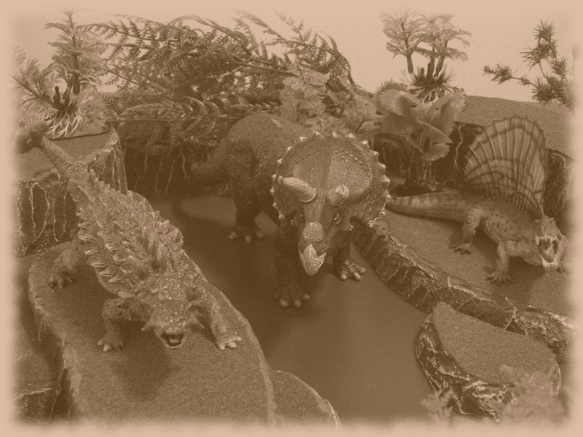

Traits

Traits differentiate an entity by providing a unique way of hampering enemies or boosting their own abilities.
This section deals with acquiring and managing Traits and a list of all available Traits.

Maximum Traits
An entity can have a maximum of 3 Traits.

Trait Categories
The 2 categories of Traits are Active (used to provide a temporary bonus during combat) and Passive (flat bonuses and "always on" abilities).
An entity may have any combination of Active and Passive Traits (for example one of each, or only three Active, etc.). An entity cannot have the exact same Trait multiple times.

Trait Stages
Stronger versions of some Traits are available. These are named the same but have numerals after the name (for example "Sprint II").
An entity must learn the lower stage of Trait before advancing to the next one.

Higher stage Traits are always used instead of their lower stage counterparts.
For example an entity wouldn't use Thick Skin I and Thick Skin II; they would just use Thick Skin II for +4 Defense. Similarly taking Bonus HP I, Bonus HP II, and Bonus HP III would use +9 Hitpoints from the top stage Bonus HP III.

Active Traits
Active Traits provide a special temporary bonus or effect beyond what an entity could normally do.

Usage: At the start of their Activation an entity can specify if they are using any Active Trait(s), unless otherwise mentioned in the trait Effect.
Once used Active Traits last until the start of the next Activation of the entity.
Each Active Trait can only be used by an entity once per encounter. Once used write a checkmark beside the Trait name on the Posse Roster to mark it as used.

Passive Traits
Passive Traits provide a bonus or benefit to the entity in the form of a permanent static modifier.

Usage: When a Passive Trait is chosen, any bonus it confers is immediately applied to the entity (if possible) or always used in the required situation (for example "Charger").

Traits List
The following lists outlines all Traits an entity can choose. Each trait has a Name, then all available Stages are listed, the Effect (with a "/" denoting any increased benefits at each stage), and then whether a Human or Dinosaur (or Both) can have the Trait.

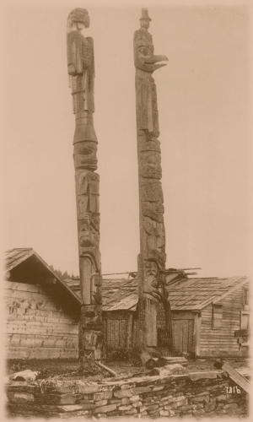

Standalone Game

Competing against an equally matched Posse in a one-off encounter is easy and fun to do. This section deals with the steps necessary to organize a standalone game.

Step 1/5 - Decide on Details
All players need to agree on some details before the encounter can start.

Variant Rules: Check with your opponent(s) if they like to use any custom modifications. See the Variant Rules section. Mark the Custom Game Sheet to help remember what is used.

Posse Quality: Normally a Posse starts with 100 Improvement Points (IP), 1,000 ND (Neodollars) and 3 Traits, but higher values can be used as long as both Posses have the same.
Try to maintain a 1 IP to $10 ratio to ensure entities have proper equipment for their skill level.
Also try to give 1 Trait per 30 IP so that special abilities match skills.

Table Size: Agree upon a table size, normally 4 feet long and 3 feet wide is used. Larger tables hamper melee entities and reward shooting, while the reverse is true for smaller tables.

Deployment: See the Deployments section for different options to set up the Posses.

Objective: See the Objectives section for details on choosing a goal for the encounter. Normally a single objective is used for all players, but secret individual objectives can also be used.

Features: See the Features section to decide if any additional special events will be used. These normally add some variety and chaos to a battle without affecting the deployment or objective. Use the Custom Game Sheet to help remember what Features are in use.

Step 2/5 - Hire a Posse
Players should now create a Posse using the Improvement Points and Neodollar values decided in Step #1. Fill in a blank Posse Roster with the result.

Multiplayer Game: For each additional player beyond two add +2 HP (at no cost) to every entity in your Posse (for example +6 HP for a five player game).

Step 3/5 - Set Up Table
Using the table size agreed upon in Step #1, take turns adding terrain features to match the current objective and features or location of the encounter.

Step 4/5 - Deploy Posses
Once the table is set up each player rolls a D12 (re-roll ties). Whoever rolls highest deploys first following the restrictions agreed upon in the Deployments section. Next the second highest roll deploys and so on until all players have deployed their Posse.

Step 5/5 - Start the Game
Now the game can begin, so start the first turn!
Unbalanced Posses and Encounters
In some cases a Posse may be forced to fight opponents far above their skill level. This is especially true in competitive campaign games with multiple players. When against a superior force a Posse will be as focused as possible, and if they survive are sure to learn a lot.

Before an encounter compare the IP Total for all involved Posses. Depending on the difference in IP, the weaker Posse may receive a bonus. The bonuses cumulative so combine any lower effects as well.

IP Gap | Unbalanced Posse Bonus
20 | Additional Yeehaw! usage
50 | +1 Initiative
100 | +1 Initiative, +1 IP per enemy entity Out of Action
150 | +1 IP per enemy entity Out of Action
200 | +1 Initiative
250 | +1 IP per enemy entity Out of Action
300+ | +1 Initiative

For example Hope's Wardens (110 IP Total) are tasked with stopping The Death Snakes (270 IP Total). The difference in IP Total is 160 (270 - 110), so Hope's Wardens would have an additional Yeehaw!, a +2 Initiative bonus and +2 IP awarded per enemy entity Out of Action.

Tips for New Players
Learning a new game system can be daunting, so here are a few helpful tips and tricks to better understand the finer points of the rules.

Remember the Objective: Always recognize that the objective will help you win the game. Taking enemies out of action is fun, but if you're supposed to escort a civilian across the table it won't matter how many enemies are down.

Activation Order Tips: Keep in mind that WHEN you activate your posse members matters. Consider activating someone low on Hitpoints early on in the turn, so that they can do something before being taken out of action. Similarly if an entity is vulnerable move them first to get the "Movement" Defense bonus. If you're going to engage an enemy in close combat do any shooting first with the rest of the posse to avoid the "In Close" penalty.
If you have any surprise or trick moves save them until later in the turn, so that your opponent cannot react as well. Instead consider activating obvious, simple moves first.

Yeehaw! is Versatile: The Leader's Yeehaw! ability is typically used to re-roll an attack, but keep in mind it's quite versatile and can apply to ANY roll an entity makes. For example re-rolling a failed Charge could be critical, or a Bravery Test, or even the Heal amount on a Medical Device. Consider the position of the Leader as well to ensure any posse members who possibly need the Yeehaw! re-roll are within 12".
Phase Flexibility: Remember you can perform the Action phase BEFORE Movement, such as to "shoot and scoot" into cover or further from the enemy. You aren't forced to move first.

Handling Enemy Dinosaurs: There are generally two approaches for enemy dinosaurs: kill them early or ignore them. There is no point in half focusing on a dinosaur, getting it to 10 Hitpoints remaining, but not actually taking it out of action. Either commit or don't bother.

Risking Snap Attacks: Sometimes leaving a close combat (especially an unwinnable situation) can be worth suffering a Snap Attack. This is especially true if the rest of your posse could shoot the target, or if there is some control effect (like Stopped) to prevent the enemy from following.

Consider Brawl/Beast Attacks: Close combat weapons are good, but never forget the versatility of Brawl or Beast attacks. Look at the situation and see if a Shove or Trample would do more damage by pushing the enemy into a solid/impassable surface or off a cliff. This is especially true if the enemy is nearly taken out of action and the extra 1 or 2 damage could make the difference.

Deployments
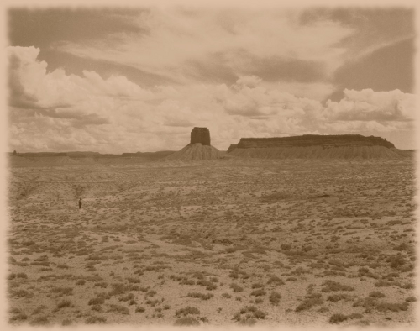
Random Deployment: Each deployment name has a number beside it in brackets. If the players wish to use a random deployment roll a D12 and use the deployment that matches the result.

Distances: These deployments generally use an 8" or 12" deployment restriction. This measurement is based on a 4'x3' table, and can be adjusted accordingly to accommodate different table sizes.

Rolls: In some cases a deployment may call for a D12 roll (to decide table edges, quadrants, etc.). If this is required designate a North table edge and consult the following after each roll:

Roll of 1-3 = North, 4-6 = East, 7-9 = South, 10-12 = West

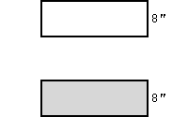
Edge (1)
If the table is a rectangle choose (or roll) for short or long table edges to be used. Otherwise choose two opposite table edges to use.
The first Posse will deploy within 8" of a table edge, followed by their opponent within 8" of the opposite table edge.

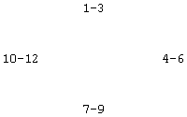
Random Edge (2)
The first Posse will roll a D12 to decide what table edge they will use.
The Posse deploys within 8" of the designated table edge. Their opponent will then roll and deploy in the same way (re-roll if the table edge result is the same).

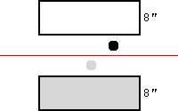
Deep Edge (3)
Designate a single unmounted character in each Posse who will be the scout.
Proceed with a standard Edge deployment, except for the scout.
The first Posse will then deploy their scout between 8" from their table edge to the middle of the table, followed by the second Posse.

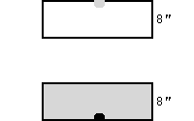
Delayed (4)
Designate a single entity in each Posse who will be delayed.
Proceed with a standard Edge deployment, except for the delayed.
At the start of turn 2 roll a D12 for each delayed entity. On a result of 7+ the entity is deployed within 4" of a random table edge.
For each undeployed entity at the start of each turn continue rolling a D12 with a +1 roll modifier per turn (such as +3 on turn 3).

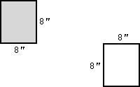
Corner (5)
If the table is a rectangle choose (or roll) for short or long table corners to be used. Otherwise choose two opposite table corners to use.
The first Posse will deploy within 8" of a table corner (two intersecting table edges), followed by their opponent who will do the same in the opposite table corner.

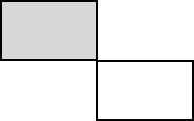
Deep Corner (6)
Proceed with a standard Corner deployment, except that instead of being within 8" of the corner each Posse can go to the middle of the table.

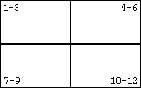
Quadrant (7)
Split each Posse in half. The first Posse will roll a D12 to decide which quadrant to deploy their first half to.
The second Posse will roll a D12 and also deploy half their Posse, re-rolling if the result is the same quadrant.
Repeat this process for the remaining half of each Posse.

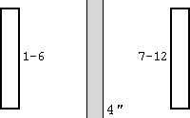
Line (8)
The first Posse deploys within a 4" wide strip as long as the table. No entity may be within 5" of another.
The second Posse then deploys within 8" of a random table edge that is opposite the wide part of the line.

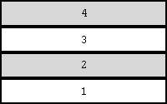
Layered (9)
Split the table into 4 equal zones. The zones can be lengthwise or widthwise. Designate the south zone 1 and north zone 2.
Split each Posse in half.
The first Posse deploys half in zone 1, the second Posse deploys half in zone 2. Next the second Posse deploys their remaining half in zone 3 and finally the first Posse deploys half in zone 4.

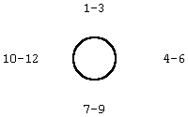
Center (10)
The first Posse deploys within 12" of the center of the table.
The second Posse rolls a D12 and deploys within 8" of a random table edge.


Diagonal (11)
The first Posse chooses a corner and diagonally draws a line to the opposite corner. They deploy anywhere in one of the zones created.
The second Posse then deploys in the opposite zone.


Scatter (12)
Posses alternate deploying a single entity anywhere on the table.
No entity can deploy within 3" of another.

Objectives
Random Objective: Each objective name has a number beside it in brackets. If the players wish to have a random objective roll a D12 and use the objective that matches the result.

Secret Objective: Instead of a single objective both players are competing for, each player can have their own secret objective that might be different than their opponent.

Objective Markers: An objective may call for an objective marker. This is a generic term for any number of possible objectives, such as an important hill, diamond mine, baby dinosaur, banner or flag, road intersection, etc.
Providing a benefit during the encounter for controlling an objective can help encourage players to capture them, for example instead of plain crates as an objective marker use the Feature "Ammo Container".

Set Turn Limit: An objective may declare that a turn limit is used. Unless otherwise specified the recommended number of turns is 6. At the end of the last turn the encounter ends.

Variable Turn Limit: Set a turn limit, and when that limit is reached roll a D12. On a result of 7+ the encounter continues for a turn. Then at the end of the next turn roll another D12. On a result of 8+ the encounter again continues for a final turn. At the end of these two possible turns the encounter automatically ends.

Situational Turn Limit: Set a turn limit with bonus turns given when certain encounter conditions are met. Agree with your opponent on what conditions to use ahead of time, and extend the encounter by 1 turn if a situation happens. For example a situation could be an extra turn if neither player has entities beside an objective marker by turn 6.

Shoot Out (1-2)
Victory: The first Posse to concede or have all their entities Out of Action loses, and their opponent wins.

Quick Draw (3)
Victory: The first Posse to concede or have 3 entities Out of Action loses, and their opponent wins.

Assassinate (4)
Setup: Add +2 HP to every Leader.
Victory: The first Posse to have their Leader taken Out of Action loses, and their opponent wins.

Strike Fear (5)
Victory: The first Posse to have 4 entities Out of Action and/or take 4 Bravery Tests loses, and their opponent wins. Passing or failing a Bravery Test is irrelevant, only that it was taken. Bravery Tests from a Leader being taken Out of Action do not count.

Capture (6)
Set Up: Choose a number of objective markers and place them in an agreeable way with your opponent. Objective markers may be anything and do not have a specific size. For example there could be a single objective in the middle or multiple scattered around the table.
Victory: At the end of the turn limit whoever has the most objectives with allied entities within 4" wins.
If both allied and enemy entities are at an objective it is considered captured by whoever has more living entities within 4".

Smash and Grab (7)
Set Up: Place a single objective marker in the center of the table. The objective marker must be small enough that a single character can realistically carry it.
A character can pick up the objective marker by spending their Action Phase.
If the character is taken Out of Action the objective marker is dropped where they were.
Victory: The first Posse to carry the objective marker off a table edge wins.

Defend (8)
Set Up: Choose an attacker (+1 Initiative bonus) and defender. After Deployment the defender places a single objective marker within 8" of an allied entity.
Victory: At the end of the turn limit whoever has more living entities within 4" of the objective marker wins.

Flank (9)
Set Up: Choose an attacker (+1 Initiative bonus) and defender.
After Deployment the attacker places an objective marker a minimum of 30" from an allied entity.
Victory: The attacker wins if at least half their Posse are within 4" of the objective marker. The defender wins if they can prevent this.

Escort (10)
Set Up: Choose an attacker and defender (+1 Initiative bonus). The defender must escort a Civilian across the table, while the attacker must kill the Civilian. The name and details of the Civilian will vary based on the defender, but the statistics that are used should be:

Civilian
DEF 0, RTN 7, CTN 7, BTN 8, SPD 4, HP 10, Escape.
80kW Six-Shooter, Small IRP.
Use the Civilian as if they were part of the defender's Posse

In addition the Civilian will be stronger based on the defending Posse:
For every 50 Total IP the defender has increase the Civilian HP by 2.
For every 100 Total IP the defender has increase the Civilian DEF by 1.
For example a defending Posse with a basic 100 Total IP would have a Civilian with DEF 1 and HP 14. Whereas a defending Posse with 350 IP would have a Civilian with DEF 3 and HP 24.
Victory: If the Civilian is Out of Action the attacker wins. If the Civilian moves off the furthest table edge from the defender's deployment the defender wins.

Guard (11)
Set Up: Choose an attacker (+1 Initiative bonus) and defender. The defender must protect a Civilian while the attacker tries to kill them. Use the statistics from the Escort objective above.
Victory: If the Civilian is alive at the end of 6 turns the defender wins, otherwise the attacker wins.

Demolish (12)
Set Up: Choose a number of objective markers and place them in an agreeable way with your opponent. Each objective marker needs to be destroyed, and has the following statistics:

Objective Target
DEF 2, HP 10

Victory: The first Posse to destroy the majority of the objective markers wins.

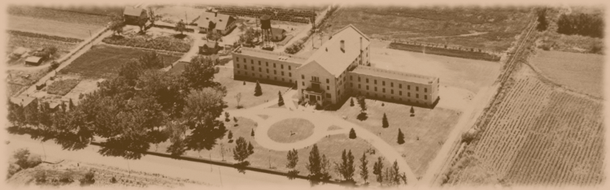

Features
Pit Fight
Only close weapons, Brawl attacks, and Beast attacks can be used.

Street Fight
Characters can only use range weapons.

Out of Supplies
At the start of the encounter mark all range weapons with a Reload token.

Weapon Emplacement
Place any number of weapon emplacements around the table. Any character adjacent to the emplacement can use their Action Phase to attack with the weapon. Use any of the range weapons from the Range Weapons list. Recommended options are Gatling Gun, 10-Pound Cannon, Rocket Launcher, and any Grenades.

Shield Generators
Place any number of shield generators around the table. Any entity within 2" have +1 Defense.

Siege
Distant cannon fire is bombarding the table.
Cut out D6 circles of paper about 1" wide. At the start of every turn drop these circles from 2' above the table. Wherever they land is where the cannon fire hit.
Any entity within 6" of a cannon shot suffers a 2A-5D, RTN 7 attack.

Generic Terrain Features
Various ideas for placing unique terrain that can change the flow of battle.
Town: Place numerous town buildings on the table. They may be inaccessible or humans can enter them (use a grid or square board for the floor plans).
Road: Place a stretch of road, trail, or other improvement on the table. Entities have +1 Speed if their move starts on the road. This bonus applies to Standard Move, Hustle, and Charging.
Marsh: Place various patches of marsh and bog that will either slow movement (-1 Speed until the end of next Activation after passing through a marsh) or are entirely impassable.
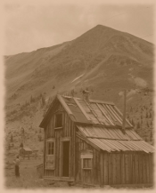
Swamp: The ground is flooded and deadly to humans. Dinosaurs can ignore the swamp and move as normal. Place numerous steep hills within 2-4" of each other. Humans must jump from hill to hill to move around the battle. If they touch the swamp they suffer D6 damage.
Broken Ground: Covers the entire table. No entity can Hustle or Charge.
Canyon: Place tall hills, cliffs, and walls along the table with a central ravine or clearing running down the middle.
Chasms: Place any number of straight lines of random length. These chasms threaten movement for humans, but not dinosaurs. Humans can cross on a roll of 6+ on D12, on failure they take 1 damage.
Volcano: Place a volcano on the table, which is dormant at start of the encounter. At the start of each turn roll a D12. If the result is greater than or equal to 8 (minus the current turn number) the volcano erupts.
Once erupting, lava expands in all directions from the volcano at a rate of 6" each turn. Any entity touching the lava suffers 3D12 damage. Entities at higher elevation are safe for 1 turn per 1" of height.
Forest Fire: Place any number of fires on the table, generally 4"x4". At the start of each turn roll a D12 for each fire. On a roll of 8+ the fire will grow by 1" in every direction.
Any entity who comes into contact with fire will suffer D6 damage.
Carnivorous Plants: Any character within 2" of a tree (or other vegetation based piece of terrain) must roll a D12 at the start of their Activation. If the result is 8+ the tree immediately attacks with 6A-0D, CTN 6 attack.
Light Fog: Covers the entire table. No range attacks at Long Distance.
Heavy Fog: Covers the entire table. No range attacks at Medium or Long Distance.
Light Duststorm: Covers the entire table. Use a roll of 1 or 2 to count towards a Reload.
Heavy Duststorm: Covers the entire table. Use a roll of 1, 2, or 3 to count towards a Reload.
Extreme Temperatures: Covers the entire table, forcing characters into the shade. Any character that does not end its Activation in a building, adjacent to a piece of Cover (such as a tree), or adjacent to (or mounted on) a dinosaur, suffers an automatic 1A-1D, CTN 5 attack from the extreme temperatures.
Gold Mine: Place a gold mine on the table. Any entity who uses an Action Phase to mine this location will receive $10.
Inspiring Ruins: Place any number of ruins on the table (affects anyone within 4" of a ruin) or have this effect cover the entire table.
Reduce all base Target Number numbers by a -2 bonus (for example 7+ to hit would become 5+).
Fearful Ruins: Place any number of ruins on the table (affects anyone within 4" of a ruin) or have this effect cover the entire table.
Roll 2 dice for any Bravery Test and use the lowest.
Gusting Winds: Covers the entire table. All attacks add 2" Pushed.
Clear Day: Covers the entire table. All range weapons have +5" to their maximum Long Distance.
Sunset: Covers the entire table. Choose Dusk or Night. When an entity is hit with a range weapon they roll a D12. If the result is 10+ (Long distance at Dusk or Medium distance at Night) or 8+ (Long distance at Night) the attack has no effect.
Blinding Sun: Designate a table edge where the Blinding Sun starts. At the end of every turn move the Blinding Sun clockwise to the next table edge. At the start of the encounter designate a penalty that applies to any range attacks towards the Blinding Sun table edge. The penalty can be -1 Attack (minimum 1), -1 damage (minimum 0), no attacks at 15"+ Distance, no attacks at Long Distance, or no Critical Hits.
Refreshing Spring: Place a fountain or spring on the table (affects anyone within 4" of the spring) or have this effect cover the entire table.
Every entity regenerates 2 HP at the end of their Activation.

Body of Water
Place various water terrain features across the board, such as rivers, ponds, and lakes. Then designate what type each is. Regardless of the primary effect all water counts as Difficult Terrain.
Strong Current Water: For every 1" of Movement within the water, the entity is placed 2" towards the nearest table edge.
Vortex Water: Upon entering or Activating a character within the water, roll a Bravery Test. On failure do 1 damage to the character (from drowning).
Populated Water: Upon entering or Activating within the water, make a 2A-2D, CTN 7 attack against the entity from all the vicious dinosaurs lurking under the surface.
Murky Water: Triple the Speed cost for moving through the water.
Muddy Water: Entities cannot use a Charge action from within, or across, the water.
Deep Water: Count as Difficult Terrain even for dinosaurs.
Stagnant Water: +1 Defense to any entity attacked within the water.
Impassable Water: No entity can move through the water.
Refreshing Water: Upon Activating within the water the entity gains 2 HP.
Noxious Water: Upon exiting the water the entity is Stunned.
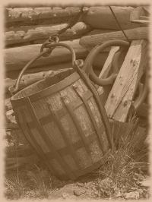
Containers
Place various crates, barrels, and canisters around the table. Designate what type each set of containers is. Regardless of the primary effect all containers provide Cover.
Exploding Container: Can be attacked with statistics of 0 Defense and 4 HP. When taken Out of Action apply a D6" Explosion with 5 Damage, and then remove this container from the table.
Fortified Container: Provides additional Cover for a total of -2 damage.
Ammo Container: Adjacent characters ignore any dice in an Attack Roll that necessitates a Reload.
Stable Container: Adjacent characters can attack with a range weapon at +5" maximum Long Distance.
Sturdy Container: Adjacent characters can attack with a range weapon with a +1 Attack bonus.

Tunnels
Place pairs of entrances/exits to tunnels around the table. Designate whether dinosaurs can fit into the tunnels.
Hidden Tunnel: Any entity reaching an entrance can instantly move to the matching exit. Doing so ends their Movement Phase.
Slow Tunnel: As per Hidden Tunnel, except the entity will not appear at the exit until the start of their next Activation.
Complex Tunnel: Use a grid or square board sections to represent the tunnels. Make sure entrances and exits are marked on the grid. Entities who enter the tunnels can move as normal underground on the grid.

Traps
The players agree on the number and type of traps each can use. Each trap is 4"x4".
Traps are placed before deployment. Each player writes down the X and Y coordinates (in inches) of where they want to place each trap, which will remain hidden until sprung.
If an enemy entity moves into the trap immediately resolve the effect, then the trap is removed.
Spike Trap: D6 damage, +2 if the target Hustled when they entered the trap.
Flame Trap: D6 damage, and another D6 damage at the start of the target's next Activation.
Falling Log Trap: D12 damage, 4" Pushed (away from nearest enemy entity).
Deadfall Trap: 1A-4D, CTN 5 attack.
Grenade Trap: D6 damage, 2" Explosion.
Foothold Trap: 2 damage, Stopped.
Snare Trap: 2 damage, Slowed.
Boulder Trap: 2 damage, Stunned.
For example Jim and Sally agree to have 1 Boulder Trap each. Jim writes down his trap location coordinates. He places the 1 Boulder Trap 18" from the west of the table (X coordinate) and 12" from the north (Y coordinate). Any of Sally's entities that move within 4" of the coordinates 18"x12" will spring the trap, which means suffering 2 damage and Stunned.

Stampede
A large herd of unstoppable dinosaurs can be a frightening sight.
Place a herd of Ducky, Thickskull, Horned, or Longneck dinosaurs on the table. The herd should be at least 3" wide and 5" long, and cannot start within 12" of any entity.
At the start of each turn the dinosaurs move towards the nearest entity for their full movement. The herd ignores Difficult Terrain.
Any terrain (trees, hills, etc.) the herd passes over is trampled and removed.
Any entity in their path suffers a standard attack from the dinosaur type, but with 6" Pushed.

Hiring a Posse
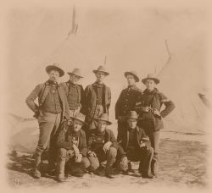
A Posse is a group or gang of up to five characters and one dinosaur who travel across wild plains and steaming jungles battling feral beasts and foes of all kinds. This section will familiarize you with the process of filling out a Posse Roster (a blank copy is at the end of this rulebook).

Step 1/7 - Choose Posse Name
Choose a Name for the Posse, and write it in the empty space at the top of the roster.

Step 2/7 - Posse Starting Statistics
All Posses start with the following group statistics. Fill in each associated field at the top of the roster.

IP Current: 100 (remaining Improvement Points)
IP Total: 100 (total available Improvement Points)
ND Current: $1,000 (remaining Neodollars)
ND Total: $1,000 (total available Neodollars)

Step 3/7 - Hiring
Each Posse must start with 3 entities. There must be 1 Leader, 1-4 Members, and up to 1 dinosaur.
For example a Posse could start with 1 Leader, 1 Member, and 1 dinosaur. Or perhaps the Posse has 1 Leader, 2 Members, and no dinosaur.

- The Leader is free to hire.
- The first Member is free to hire (see the Hiring a Character section).
  - Each additional Member costs $200 initially, or $250 later (in the case of a Campaign).
- Dinosaur prices vary from $300 to $1,000 (see the Hiring a Dinosaur section).

Leader: See the Hiring a Character section, and grant the following benefits for being the Leader. Note if a Leader is taken Out of Action every allied character must immediately take a Bravery Test.

Benefits: -1 BTN, +2 HP, Yeehaw! ability

Yeehaw! (Leader Ability)
- Once per encounter another allied entity within 12" can re-roll a single dice. Mark the ability as used on the Posse Roster.

Step 4/7 - Advance Characters
Each Posse can spend their Improvement Points amongst their characters in any manner they choose. Not all of the points have to be used; any leftover points should be recorded in the "IP Current" field at the top of the roster.
Dinosaurs cannot use Improvement Points.

Spending Improvement Points: Changing statistics from their base value (either increasing or decreasing) is done using a sliding scale that is built around the default value of each statistic. See the Statistic Improvement Costs section to find the IP cost to modify a statistic.

The cost is for each "step" of improvement.
For example raising Speed from 4 to 5 would cost 12 Improvement Points, and an additional 14 points for 5 to 6 (or a total of 26 Improvement Points to improve directly from 4 to 6).

Voluntary Weakness: Some statistics can be voluntarily weakened to gain additional Improvement Points that can be spent elsewhere. This is noted as "+X" in the cost tables.
For example voluntarily decreasing Speed from 4 to 3 would give 5 Improvement Points, similarly weakening Bravery Target Number from 8 to 9 would give 2 Improvement Points.

Step 5/7 - Allocate Traits
Each Posse begins with 3 Traits to choose and allocate to any entity or set of entities. See the Traits section for details.
Traits cannot be removed once they have been allocated.
For example one character might get 1 Active Trait, another gets 1 Passive Trait and their dinosaur chooses an Active Trait. Or one character could be greedy and take 2 Active Traits and 1 Passive Trait.

Step 6/7 - Equip the Posse
Spend any remaining Neodollars on weapons, armor, and equipment for any characters in the Posse. Record leftover money in the "ND Current" field at the top of the roster.

Step 7/7 - Fill in Remaining Fields
The Posse Roster should now be populated with details of your entities, but double check it to ensure no unnecessary blank fields remain.

Hiring a Character

Each character in a Posse plays an important role in the continued survival and advancement of the group. Some may be long distance specialists, melee bruisers, supporting doctors, or any other role their statistics and personality help define.
This section is used to hire a custom character as part of a Posse and defines how to fill in each character block of the Posse Roster.

Step 1/3 - Choose Character Name
Even though the year is 2285, names common in the 21st century are still valid and not unusual.
Choose a Name for the character, and write it in the space marked "Name".

Step 2/3 - Choose Allegiance
Choose an Allegiance for the character from the four detailed below. Apply any modifiers to the default base values for each statistic, and remember to calculate improvement costs using the modified statistic.
When marking the Allegiance on the Posse Roster, circle the corresponding letter in the box to the left of the "Name" field (for example "D" for Duster).
Characters in a Posse can be different Allegiances, and each character must have an Allegiance.

Duster
Dusters scrape a living out of the desert in shanty towns and fields. Although a little slow on their feet, they are rough and tough from a physically demanding life.

Effect: -1 SPD, +2 HP

Neotechnoist
Neotechnoists hail from the jungle surrounding the volcano. Although somewhat unaccustomed to hardship, they have had many opportunities to access and study technology and modern weapons.

Effect: -1 RTN, -2 HP, Wealth ($10 refund on first weapon purchase)

Savage
Savages live wild and feral in the wastelands away from civilization and sometimes band together in tribes to hunt a powerful dinosaur. Although unfamiliar with modern weapons, they are lightning fast from surviving on the edges of society.

Effect: +1 RTN, +1 SPD

Bandit
Bandits come from all walks of life and may just be trying to survive, or they can be downright morally bankrupt. They are survivors, tinkerers, and jack-of-all-trades and therefore have no glaring strengths or weaknesses.

Effect: None

Step 3/3 - Starting Statistics
Fill in the default base values for each statistic in the provided field on the Posse Roster. These statistics can be improved by spending Improvement Points.
Note SPD and HP have space for half value (used with Hustle and Bravery Tests respectively).

Target Numbers: Remember lower values are better for RTN, CTN, and BTN because they define the base Target Number for what is needed on a roll to succeed.

Statistic Improvement Costs
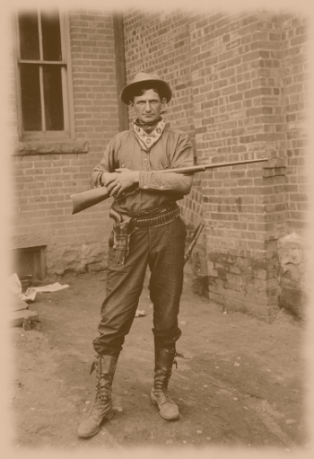

Hiring a Character Example
This example will demonstrate the process to hire a character. Included is choosing and applying the Allegiance, improving statistics, selecting a Trait, and buying equipment.

Name: We name our character "Quidel", and he'll be the Leader of our example Posse. Since he's a Leader he automatically gets -1 BTN and +2 HP, which means his starting statistics are:
DEF 0, RTN 8, CTN 8, BTN 7 (8 - 1), SPD 4, HP 10 (8 + 2)

Allegiance: Quidel grew up in Nevada and only knows the hardship of life outside The Wall. Therefore his Allegiance will be Duster. This means he has an additional +2 HP, but -1 SPD. His statistics are now:
DEF 0, RTN 8, CTN 8, BTN 7, SPD 3 (4 - 1), HP 12 (10 + 2)

Statistics: The plan for Quidel is to advance across the field firing his range weapons before closing into melee. Therefore he'll be passably trained in shooting and close combat without being overly specialized in either.
The first statistic to improve is Range Target Number. We're improving from 8 to 7, which costs 10 IP (as shown in the Statistic Improvement Costs section).
Improving his Close Target Number from 8 to 7 is a similar cost of 10 IP. His statistics are now:
DEF 0, RTN 7 (8 - 1), CTN 7 (8 - 1), BTN 7, SPD 3, HP 12

Since he's our Leader some additional survivability would help. To this end we purchase +2 Hitpoints. At 6 IP per +1 HP, we've spent an additional 12 IP. We'll also give him a base Defense of 1 for 10 IP. His final statistics are:
DEF 1 (0 + 1), RTN 7, CTN 7, BTN 7, SPD 3, HP 14 (12 + 2)

Traits: Let's decide to allocate a Trait to Quidel. In this case we'll choose the first stage of "Attack - Berserker", a solid Active Trait option that gives +2 Attacks once per encounter.

Equipment: Finally we need to equip Quidel. A basic gun will do to start, so we check out the Range Weapons list and decide on the 80kW Six-Shooter (4A-0D) for $10. It's cheap and relatively effective. However Quidel deserves a better close weapon, so $60 is spent on a Spear (1A-6D).
To maintain the survivability theme we'll buy him a suit of Quilted Armor (DEF 1) for $50, which increases his total Defense to 2.
Finally we'll give him a Salve for $10, which can be used to heal himself or an ally.

Summary: In total we spent 42 IP and $130 to hire this character:
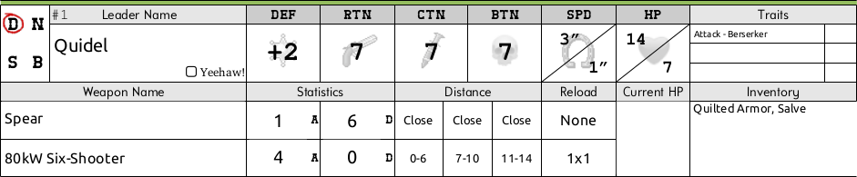

Hiring a Dinosaur

There are hundreds of dinosaurs to choose as mounts, allies, or beasts of burden. Having a loyal and steadfast companion dinosaur grants many important bonuses to a Posse. Each dinosaur is unique and has certain strengths and weaknesses that will be evident after researching the various statistics and a few battles involving them.
Note that the list of dinosaurs is not supposed to be comprehensive, scientifically accurate, or representative of which dinosaurs flourished together. Instead popular (and often misunderstood) archetypes are focused on.

Step 1/2 - Choose Dinosaur Type and Name
Choose the type of dinosaur from the list below. Pay the Neodollar amount listed under Cost to purchase them.
Fill in the dinosaur Name, Type, Size, and statistics fields on the Posse Roster.

Step 2/2 - Choose Breed
Choose a Breed for the dinosaur from the four detailed below. Apply any modifiers to the default base values for each statistic.
When marking the Breed on the Posse Roster, circle the corresponding letter in the box to the left of the dinosaur Name field (for example "T" for Trained).

Advancing a Dinosaur
Dinosaurs cannot be modified using Improvement Points, but they can take Traits.
The other customization available to dinosaurs is an advancement program that can be purchased. This is used to increase the dinosaur's Hitpoints using the following formula:

For example a Posse might want a Raptor dinosaur ($400, base 16 HP) upgraded to 19 total HP for a total of $550 (base price is $400 plus $150 for 3 HP at $50 per +1 HP).

Replacing a Dinosaur
A dinosaur will refund half its original Neodollar cost (excluding any training investment) when replaced or removed from a Posse.

Dinosaur Breeds
Similar to Allegiances for humans, the Breed of a dinosaur represents its upbringing and training. Dinosaurs may vary from savage untamed beasts to experienced mounts.

Trained
Trained dinosaurs are born in captivity or raised in a human environment soon after birth and make ideal companions. They are disciplined mounts well versed in accepting passengers and carrying them safely through battle. However they are slightly gentler from having their primal instincts suppressed.

Effect: +1 DIS, -2 HP

Plains
Plains dinosaurs roam across the flat scrub land, desert, and dust bowls outside the volcanic jungle. As a result they are exceptionally fast and agile, but are less competent with their claws because of their tendency to outrun foes instead of fighting them.

Effect: +1 CTN, +1 SPD

Feral
Feral dinosaurs are wild and free and hunt through the jungles of the world. They tend to be tougher and less disciplined, thinking more with their stomachs than brains.

Effect: -1 DIS, +2 HP

Untrained
Untrained dinosaurs have some exposure to humans but not enough to be fully broken into a saddle and harness. The majority of dinosaurs are this type of breed, and such an upbringing has no positive or negative effect on their performance.

Effect: None

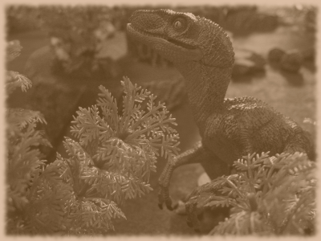

Posse Roster Example
Below is a Posse Roster that has been filled out properly. Use this as a reference as needed:

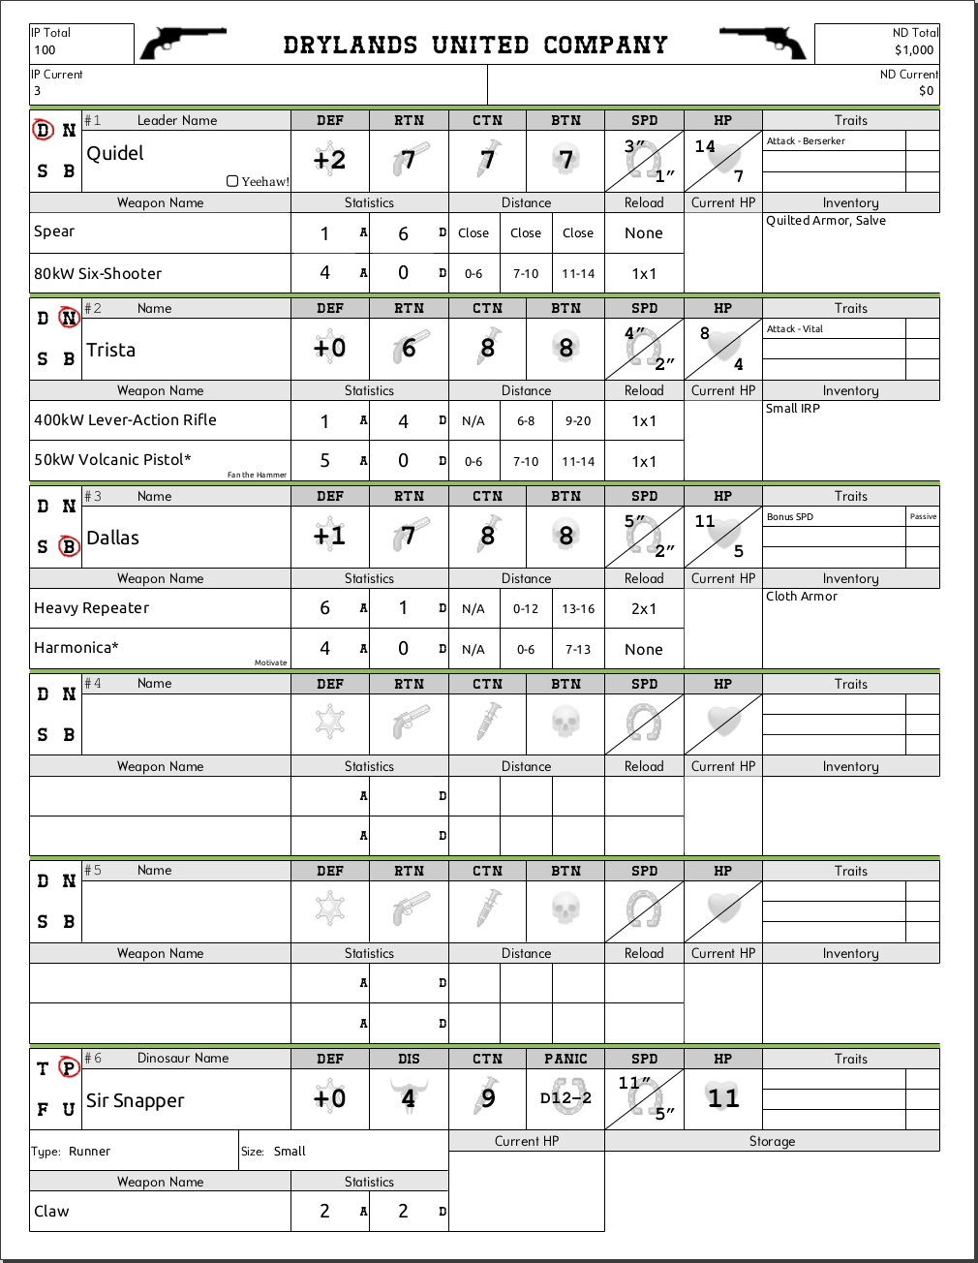

Campaign Game

Linking battles and exploration into a continuing narrative is what separates a campaign from a standalone game. In addition campaigns offer the chance to grow a Posse and have consequences between encounters. Exploring desert wastelands, vibrant jungles, sunken cities, and more is an important part of a campaign.
This section will deal with maps, travel options, towns, and post encounter effects.

The Sheriff
Although not strictly necessary, an extra player who oversees the campaign (called the Sheriff or Game Master) is recommended. The Sheriff's role is rules arbitration, map set up, controlling any unaligned enemies, moving the storyline along, and shaping the world to react to the player's actions.

Gentleman’s Agreement
Players in a campaign should also talk about what kind of play experience they want. Each player has a different idea of fun, and a good campaign results in everyone enjoying themselves.
Talking before the campaign starts can result in a "gentleman's agreement" or houserules to limit or control certain elements of the game.
For example the players might agree to limit their characters to 20 Hitpoints, or a maximum of 4 Defense, or only use 1 rifle per Posse, or make sure every character has a close combat weapon, or hire a minimum of 4 entities, etc.

Types of Campaigns
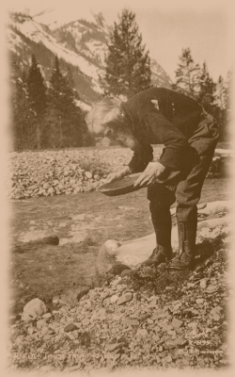
Map Based: Generally played on a hex map or real world roadmap. The goal can be area control, such as winning over towns and other territory. This requires a bit of "game to play the game" in the sense of tracking overland movement, various map terrain types, etc. Therefore this type of campaign will use the Overland Travel section.

Narrative Based: Normally a branching narrative or story is created by the Sheriff, or mutually agreed upon by all players. Then encounters are loosely strung together within this story, so that victories from earlier encounters might affect later objectives. This type of campaign is generally easier to organize and run.

Tracking Campaign Progress
To help remember encounters and their outcomes refer to the Campaign Record Sheet at the end of this rulebook.

Overland Travel
Travelling across the vast stretches of terrain that make up the future isn't as easy as it once was. Powerful land dinosaurs have replaced the automobile, and flying dinosaurs are used instead of airplanes.

Every day a Posse can travel comfortably for 6 hours. Additional travel beyond this is considered a Forced March (see below).
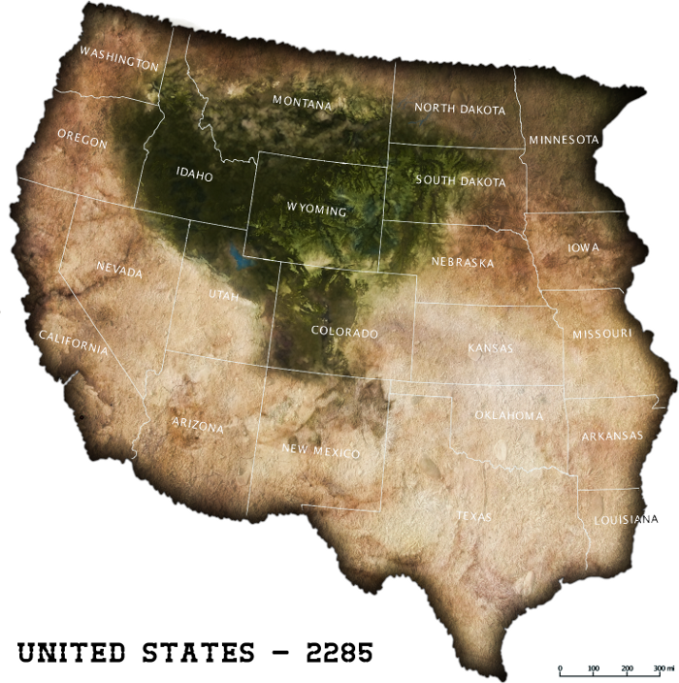
The rest of the time is spent scrounging for food and water, setting up camp, resting and sleeping, exploring nearby, or resolving encounters.

By Ground
When travelling on the Overland Map an entity's Speed statistic is converted to Miles per Hour in a 1:1 to relationship. Use the lowest Speed in a Posse for this.
For example, a character with 4 Speed could travel 4mph for 6 hours per day for a total of 24 miles on the Overland Map. If they were riding a Ripper dinosaur (7 Speed) they would instead go 7mph or 42 miles per day on the Overland Map.

Forced March: A Posse travelling By Ground can choose to perform a Forced March to cover more distance.
For every 1 hour a Posse wishes to travel beyond 6 hours they receive -1 Initiative for the rest of the day. The absolute maximum time a Posse can travel by ground is 10 hours.
For example a Posse may perform a Forced March for 3 extra hours (total 9 hours). They would have -3 Initiative for the rest of the day. With 4 Speed this would cover an additional 12 miles.

Difficult Overland Terrain: Any overland terrain except flatlands is considered Difficult Terrain (jungle, hills, desert, marsh, etc.) and has a chance to reduce the speed of a travelling Posse.
The most common types of terrain are listed in the following table. The Sheriff can expand or modify this list as necessary to suit the campaign.

When entering an area or hex on the Overland Map a D12 must be rolled. Add +1 to this roll if a road, trail, or other improvement is present. If the result is greater than or equal to the Difficulty number on the Overland Terrain table the Posse can move normally.
Otherwise they must spend an additional mile of travel to cross the terrain and they suffer any Failure Effect for that terrain.
For example a Posse wishes to cross 2 miles of Light Jungle. They would roll a D12 for the Difficult Terrain, hoping for a 5+ (as per the table). If they rolled less than 5 the Posse would have to spend 4 miles of travel to get through the Light Jungle.

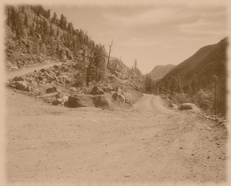

By Air
The skittish flying dinosaurs of the Pterosauria clade ("Flappers") are sometimes raised and trained as transport carriers. Unable to stand the sound and violence of gunfights, the flying dinosaurs have never succeeded as combat mounts. Instead they are used to bear cargo and human passengers and provide the ideal service of quickly moving city to city.

Pay $0.50 per mile for up to 400 miles per day (rounded to the nearest Neodollar).

The pilot and up to 8 passengers and all related gear can board a single flight. A dinosaur can take the place of human passengers depending on their Size category (Small would take 1, Medium 2, Large 3, Extra-Large 5).

By Sea
Certain breeds "Swimmers" have mounted advanced airtight ferries and been trained to take passengers across rivers and lakes. A ferry sized boat would be mounted on a Thalassomedon or Mosasaurus, whereas a sloop would be on a Nothosaurus.
Pay $1 per mile for up to 50 miles per day.

The pilot and up to 20 passengers and all related gear can board a single ferry. A dinosaur can take the place of human passengers depending on their Size category (Small would take 1, Medium 2, Large 3, Extra-Large 5).

Towns and Cities
Typically a Posse would stop at a town to fulfill a contract or job, acquire new work, restock supplies, recuperate, and basically escape the dangers of the wilderness for a while. Standard jobs can vary from escorting caravans (either wooden wagons pulled by Horned or Thickskull dinosaurs, or loaded Longnecks) to assassinations, bounties, raiding villages and camps, hunting a troublesome local dinosaur, or anything else the Sheriff can think up.

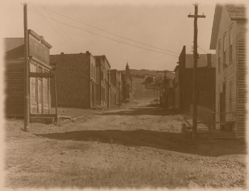
Encounters
An encounter during a campaign is organized in a similar process to the Standalone Game section. The table setup may change to match the campaign location and theme, and a preset objective that advances the plot will probably be used.

Overall an encounter is played by following these steps:
- Setup (see the Standalone Game section)
- Play (the encounter is played out between the involved players)
- Wounds and Injuries (performed for any Out of Action entity)
- Posse Advancement (gain and spend IP and ND)

Steps #3 and #4 are considered the "after encounter" stages, and are unique to a campaign.

Wounds and Injuries
In a campaign game there are lasting effects at the end of each encounter. A temporary effect is called a Wound, and a permanent effect is called an Injury. After an encounter any entity that is Out of Action must perform the following steps.

Step 1/4 - Wound Test
Roll a D12 (the Wound Test) to see if the entity is hurt or not. Dinosaurs receive +1 to this roll and Leaders receive +2.
If the result is greater than or equal to 8 the entity is unharmed and can go to Step #4. Otherwise continue to Step #2.

Step 2/4 - Determine Effect
Roll the first D6 and look in the first column on the Out of Action Effect table below. Then roll a second D6 and look in the second column to determine the effect.

Step 3/4 - Apply Effect
Apply the effect immediately as a Wound, unless the entity has any existing Wounds in the Location specified.
If the entity has an existing Wound in the Location they will suffer an Injury instead. The entity can choose to make the rolled result or the existing Wound a permanent Injury.

For example Trista suffered a Wound of "Busted Leg" in a previous encounter. She is taken Out of Action in her next encounter, so she has to see if there are further consequences.
First she rolls her Wound Test D12 to see if she's hurt. Trista isn't the Leader so she receives no bonus. Her result is 5, which is less than the target of 8, so she is hurt.
Next she rolls her first D6 for the effect, getting a 2. She rolls her second D6 getting 3, so checking the Out of Action Effect table she gets a "Broken Knee". But since she has an existing Wound in her Legs location, Trista will instead suffer an Injury. She can now decide to either make the old "Busted Leg" a permanent Injury, or the new "Broken Knee". Trista chooses the "Broken Knee" and now cannot Hustle.
Finally her old Wound of "Busted Leg" is healed and her Hitpoints are healed to full.

Step 4/4 - Recover
Unless otherwise specified, any old Wounds are healed.

Healing Wounds and Injuries: When in a town or other location with medical facilities or a doctor a Wound can be healed for $10 and an Injury for $20.

Healing Hitpoints: An entity is healed to their original Hitpoints after an encounter (unless a Wound or Injury specifies otherwise). Otherwise an entity will heal 2D12 Hitpoints naturally per day, or 4D12 if they rest (no travel, combat, etc.).

Posse Advancement
As a Posse defeats enemies and completes daring jobs they will advance from a weakling gang to a pack of hardened veterans by gaining Improvement Points and buying new equipment.

Gaining IP, ND, and Traits
- For every enemy entity taken Out of Action the Posse gains 3 Improvement Points and $30.
- If the Posse wins or succeeds at an encounter award an additional $30.
- For every 30 IP gained (regardless of the source) the Posse can select 1 additional Trait:

Traits per IP
IP | 100 | 130 | 160 | 190 | 220 | 250 | 280 | 310 | 340 | 370 | 400
Traits | 3 | 4 | 5 | 6 | 7 | 8 | 9 | 10 | 11 | 12 | 13

Recording Gains: For ease of tracking, any additional IP, ND, or Traits are calculated and recorded after each encounter, instead of immediately as they happen.

Maximum Improvement Points and Traits
The highest achievable IP Total for a Posse is 400, and 13 Traits.

Wounds and Injuries Tables
The following two tables are used during the Wounds and Injuries process.

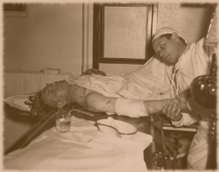

Variant Rules

These optional rules can be used by players to give a different feel to certain situations in the game. All players have to agree in advance about which rules to use (if any). Most of these variants would have added too much complexity to the game or changed the overall flavor and so were left out of the core rules.

Tracking Variant Rules
To help remember what Variant Rules are being used, refer to the Custom Game Sheet at the end of this rulebook.

Last Man Standing: The last surviving entity of a Posse does not have to take Bravery Tests (for characters) or is unaffected by Discipline (for dinosaurs).

Dual Wield: Two identical Small range or close weapons can be dual wielded, which gives a +1 Attack bonus.

Initiative Choice: Whoever wins Initiative can choose to Activate first or last, instead of automatically having to Activate first.

Initiative Focus: Once per encounter each player can use a +3 bonus to a single Initiative roll. They must declare this usage before any dice are rolled.

Critical Initiative: If a player wins Initiative by rolling a natural 12 the first entity they Activate receives +1 Speed for that Activation.

Playing Card Initiative: At the start of a two player game both players would choose a color in a standard deck of cards (red or black). Instead of rolling Initiative a standard playing card would be drawn each Activation. The player that matches the color drawn would Activate as if they had won Initiative.
Alternatively in a multiplayer game each player would choose a suit (diamonds, clubs, etc.).

Defense Damage Reduction: Directly reduce damage equal to the Defense statistic instead of modifying Target Number.

Range In Close Combat: Instead of using RTN for range weapons in close combat, use CTN instead. Still apply the "In Close" penalty.

Fumble Hit: Any unmodified rolls of 1 count as -1 Hit, to a minimum of 0 hits.

Fleeing Facing: When a character is marked with a Fleeing token immediately change their Facing to be directly away from the most recent attacker.

Fast Target: +1 Target Number penalty against targets that moved a total of 10" or more in a single turn.

Hustle Target: +1 Target Number penalty against targets that Hustled.

Maneuver - Aim: In their Movement Phase a character can Aim instead of any other maneuver. Doing so means the range attack in their next Action Phase receives a -1 Range Target Number bonus.

Maneuver - Steady: In their Movement Phase a character can Steady instead of any other maneuver. Doing so means the range attack in their next Action Phase would treat any rolls of 10+ as a Critical Hit.

Action - Dodge: In their Action Phase a character can Dodge instead of any other action. Doing so means they receive a +1 Defense bonus until the start of their next Activation.

Variable Hustle: Instead of Hustle providing an additional half Speed statistic, roll a D6 as inches instead.

Mount Protection: Passengers add their dinosaur's Defense to their own.

Downed Not Out: Instead of removing an entity when they reach 0 HP or less, place them face down instead. They cannot be Activated, take any actions, or be attacked. An ally can heal Hitpoints (using a Medical Device or Trait) to bring the Downed entity back into the fight.

Yeehaw! Action: Instead of allowing 1 re-roll in 12", this ability can provide 1 free Action Phase to any entity (even one who was already Activated) in 12".

Purchasing IP: 1 Improvement Point can be bought for $10.

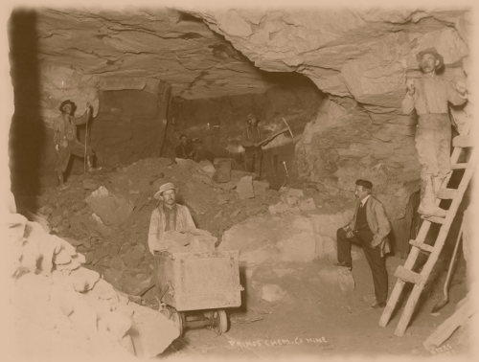

Weapons and Armor and Equipment

Neodollars
The modern currency is called a "Neodollar", and uses the prefix "$" or suffix "ND". Each bill is a durable strip of paper five inches long and one inch wide and marked with a variety of vistas from the Neotechnoist jungle. Although printing is controlled by the Neotechnoists, money still escapes into the poorer wastelands outside The Wall.

Buying and Selling
Equipment is bought by a Posse from the lists below at the listed price.
Equipment that originally cost $10 or over can be sold at half the listed price.
Equipment can be transferred between entities in a Posse (when not in an encounter).

Maximum Burden
Because of the proliferation of dinosaurs, tracking of equipment weight is not done. Instead the only limitations are based on the size category.

A character can carry a maximum of 2 Large weapons and 1 suit of Armor.
A dinosaur can store a maximum of 6 Large weapons and 3 suits of Armor.
There is no maximum number of Medical Devices an entity can carry.

Sizes: 1 piece of equipment of a larger size category translates into 2 pieces of equipment of a smaller size category.
For example 1 Large weapon translates into 2 Medium weapons or 4 Small weapons.

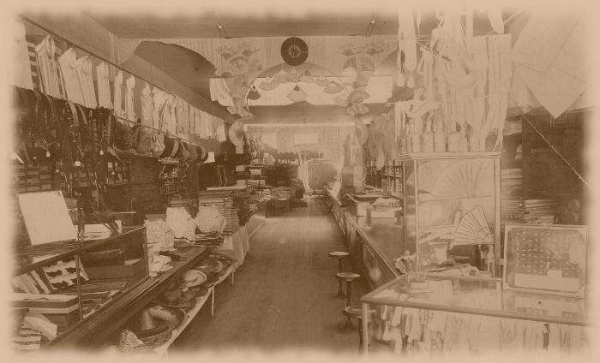

Weapon Special Abilities
There is a preset list of common special abilities that are assigned to various weapons. The description and effect for each follows.

Armor Piercing: Ignore target Defense.
Both Barrels: Add +2 Damage for the next attack, but mark with a Reload token.
Cavalry: Add +1 Damage while mounted.
Explosion: If hit any entity (allied or enemy) within the listed inches suffers the base Damage of the weapon (modified by Cover, and mounted characters take half damage).
Fan the Hammer: Can only be used at Short Distance. Add +2 Attacks and 2" Pushed for the next attack, but mark with a Reload token.
Fireline: Measure a straight line from the attacker to the maximum Distance of the weapon, in the direction they wish to attack. Any entity (allied or enemy) the line passes over (even partially) suffers a set of attacks from this weapon (modified by Cover, and mounted characters take half damage).
Hail of Shots: Optionally re-roll 1 Attack Roll dice.
Illuminate: On hit the target has -2 Defense statistic (minimum 0) until the end of their next Activation.
Lance: This weapon can only be used while mounted. Add +1 Attack and +1 Damage when performing a Charge.
Lasso: This weapon can only be used while mounted and can only target non-mounted characters. The Attack and Damage statistics are based on the mounted dinosaur.
Motivate: On a hit of 2+ total damage the attacker heals 1 HP to self or another ally in 8".
Open Choke: Add +1 Attack at Short Distance.
Opportunity: Add +2 Attacks when performing a Snap Attack.
Poacher: Add +1 Attack against dinosaurs.
Power Settings: Attack and Damage values can be changed before each attack between 5A-1D, 4A-2D, 3A-3D, 2A-4D, 1A-5D.
Pulled: If hit the target is Pulled directly towards the attacker a distance equal to the listed inches. Ignore Difficult Terrain for this movement. Dinosaurs are only affected if they are not in close combat.
Pushed: If hit the target is Pushed directly away from the attacker a distance equal to the listed inches. Ignore Difficult Terrain for this movement. Dinosaurs are only affected if they are not in close combat.
Scoped: Ignore the penalty for attacking targets in Cover.
Seeking: No Attack Roll is necessary, instead the target is automatically hit.
Slowed: On hit the target is Slowed. During their next Activation they halve their Speed statistic and cannot Hustle or Charge.
Stopped: On hit the target is Stopped. During their next Activation they cannot perform a Movement Phase, Hustle, or Charge.
Stunned: On hit the target is Stunned. During their next Activation they cannot perform an Action Phase.
Terrify: On a hit of 2+ total damage the target character must immediately take a Bravery Test.

Weapon List Information
Weapon Name: The name of the weapon, with a "/" separating any alternative names. Normally the different names are used outside The Wall compared to in.
Cost: The cost (in Neodollars) of the weapon.
Attack: The number of Attacks the weapon has.
Damage: The base Damage of the weapon. This value may be 0.
Short: The short distance of the weapon, if any.
Med: The medium distance of the weapon, if any.
Long: The long distance of the weapon, if any.
Reload: The reload, jam, overheat, or otherwise malfunction chance of the weapon.
Size: The size of the weapon, either Small (S), Medium (M), or Large (L). Used for carrying capacity.
Type: The category of the weapon, either Energy, Projectile, Grenade, Close, Brawl, or Beast:
Energy weapons are mostly laser based, especially if the Name has a Kilowatt (kW) rating in it. Otherwise Gigajoule (GJ) rated weapons fire plasma, and others use ion or energized particles.
Projectile weapons are mostly gunpowder based and similar to the weapons of the 21st century.
Grenade weapons are manually thrown at an enemy, and will always have a Reload value of Auto. This represents grabbing another grenade from a bag or bandolier. Individual grenades are not counted or tracked, so think of each Grenade weapon as a collection or pack of weapons.
Close weapons are used in close combat only and therefore have no distances or Reload value.
Brawl attacks are special natural weapons of humans. See the Close Combat Special Cases section for details.
Beast attacks are special natural weapons of dinosaurs. See the Dinosaurs section for details.
Special: Any complex effects of the weapon. See the detailed list above for each ability.

Armor List Information
A variety of armors are available for use by characters. These vary from a simple cloth shirt to more
advanced defensive materials necessary to withstand the fearsome blows of a dinosaur.

Material Name: The main material component of the armor. The style and shape varies.
Cost: The cost (in Neodollars) of the armor.
Defense: The level of added Defense protection for each suit of armor.
SPD Penalty: The amount of Speed a character loses when wearing a certain suit of armor. If this would reduce their Speed statistic to 0 or less then the character cannot wear the armor.

Medical Device List Information
Medical technology has advanced due to the proliferation of dinosaur attacks and new diseases.
Characters are able to purchase powerful healing and restorative devices to recover on the battlefield.

Device Name: The name of the device.
Cost: The cost (in Neodollars) of a single device.
Heal: The amount of Hitpoints healing that will occur when using the device.
Type: The category of device, either Instant or Delayed. See the Action Phase section for details.



